Multiple-choice section – choose the correct answer

Question 1 [6.1]

What are the values of the pronumerals *a* and *b* in the following diagram?

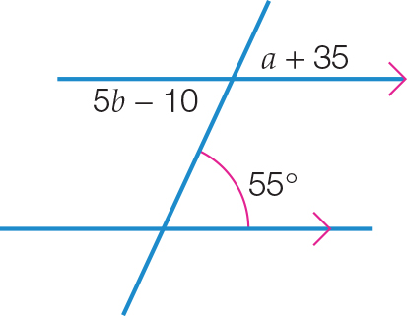

A 35°, 145°B 35°, 23°C 55°, 145°D 20°, 13°

Question 2 [6.1]

What are the values of the exterior angles *a*, *b* and *c* in the following diagram?

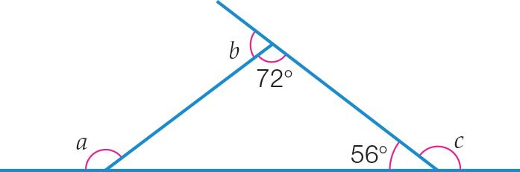

A 52°, 72°, 56° B 124°, 108°, 128° C 108°, 128°, 124° D 128°, 108°, 124°

Question 3 [6.2]

Which two triangles are congruent in the following diagram?

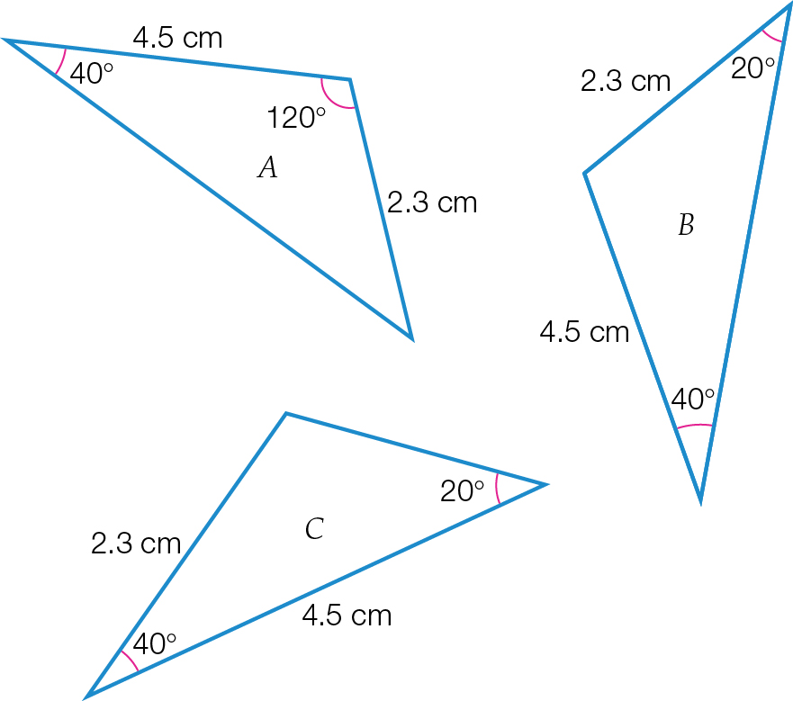

A Triangles *A* and *B*

B Triangles *A* and *C*

C Triangles *B* and *C*

D There is not enough information to decide.

Question 4 [6.4]

An equilateral triangle of side length 3 cm is enlarged to become a triangle of side length 15 cm. The scale factor is:

A  B 5 C  D 15

Question 5 [6.3]

An angle in a parallelogram measures 104°. Another angle in this parallelogram is:

A 67° B 114° C 76° D 256°

Question 6 [6.7]

The following shape has:

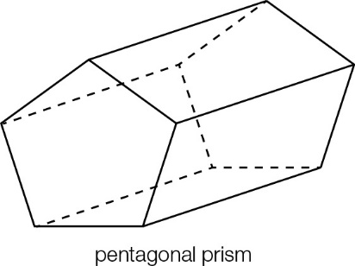

A 7 vertices, 10 faces, 15 edges **B** 10 vertices, 7 faces, 15 edges

**C** 15 vertices, 10 faces, 7 edges **D** 7 vertices, 15 faces, 10 edges

Question 7 [6.7]

A solid with two identical polygon ends and with a uniform cross-section is called a:

A prism B sphere C cone D pyramid

Question 8 [6.4]

∆*ABC* is reduced to ∆*A*′*B*′*C*′ using a scale factor of 0.5. If *AB* = 1.6 cm, then *A*′*B*′ is equal to:

**A** 3.2 cm **B** 2.4 cm **C** 1.6 cm **D** 0.8 cm

Multiple-choice results: ___ / 8

Short answer section

Question 9 3 marks [6.3]

Name each polygonandfind the values of the pronumerals for each.

**(a)**

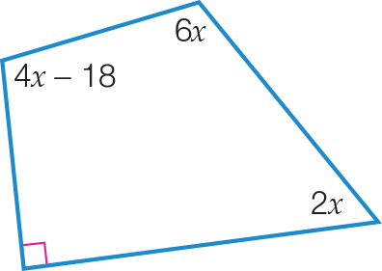

**(b)**

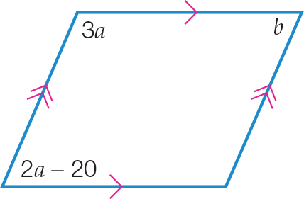

**(c)**

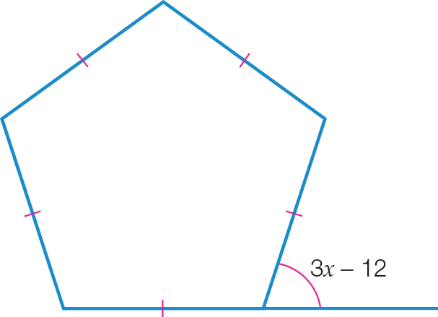

Question 10 6 marks [6.1]

Find the value of the pronumerals.

**(a)**

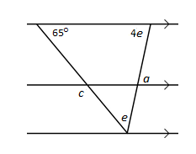

**(b)**

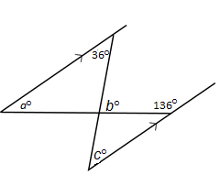

**(c)**

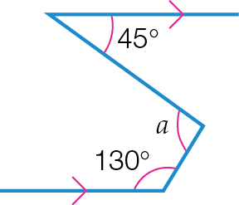

Question 11 3 marks [6.1]

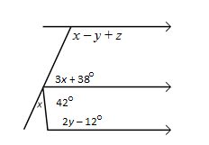

**(a)** Form an equation and solve it to find *x*. Give reasons for your answer.

**(b)** Form an equation and solve it to find *y*. Give reasons for your answer.

**(c)** Hence find the value of *z*.

Question 12 5 marks [6.2]

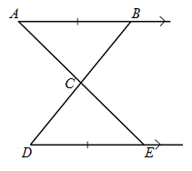

Complete the following proof by writing in the missing steps.

*AB* || *DE* and *AB* = *DE*. AE and *BD* intersect at *C*.

Prove that *AC* = *CE*.

Proof:

In ∆*ABC* and ∆*EDC*,

∠ ______ = ∠ ______ (alternate angles, *AB* || *DE*)

∠ _______ = ∠ _______ (vertically opposite angles)

________ = ________ (given)

∴ ∆ _____ ≡ ∆______ (ASA)

∴ ______ = ______ (matching sides of congruent triangles)

Question 13 2 marks [6.6]

Find the value of *x* and *y*, to 2 decimal places.

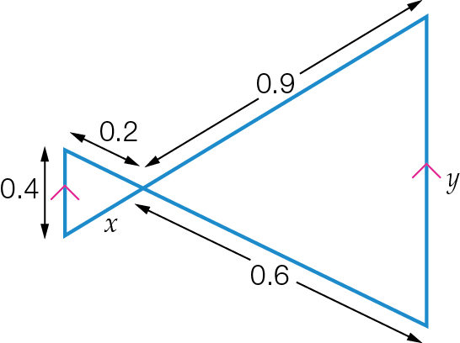

Question 14 8 marks [6.1,6.5,6.6]

Find the values of the pronumerals in the following diagrams.

**(a)**

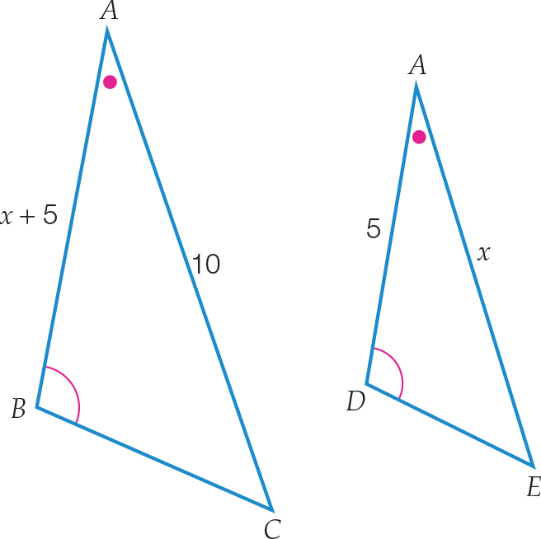

**(b)**

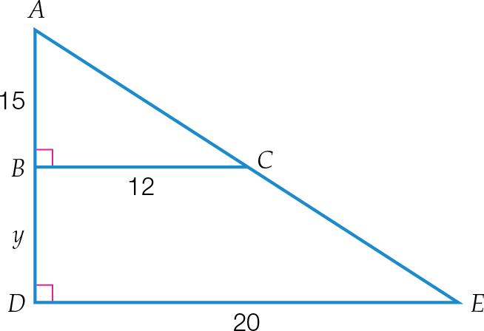

**(c)**

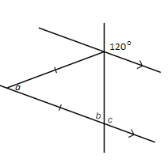

**(d)**

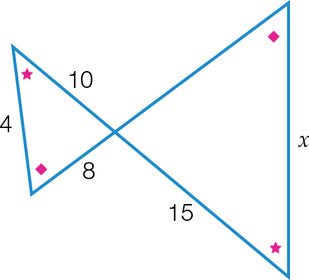

Question 15 3 marks [6.7]

Draw and label the net of this rectangular prism. Show all measurements.

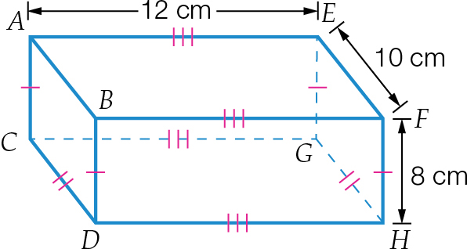

Question 16 2 marks [6.6]

Use the properties of similar triangles to find the distance across the river, correct to 1 decimal place.

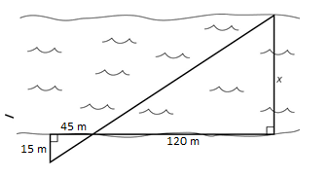

Question 17 5 marks [6.5]

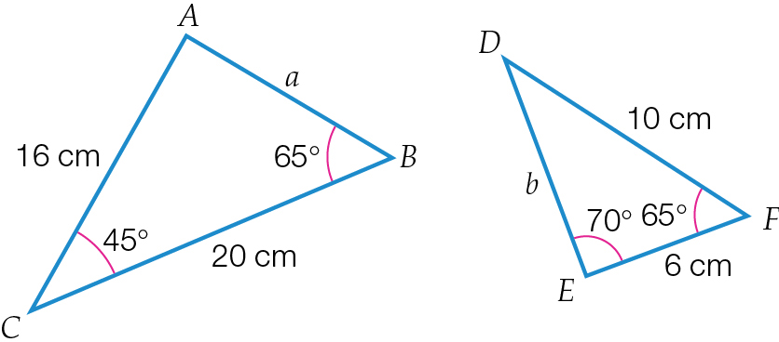

**(a)** Show that the triangles are similar.

**(b)** Hence find the values of *a* and *b*.

Question 18 2 marks [6.4]

The small pentagon has been enlarged to the large pentagon.

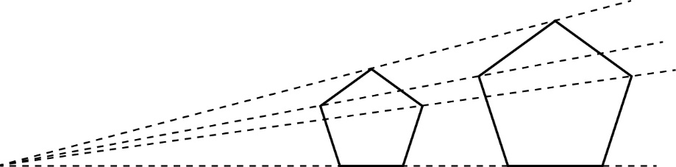

**(a)** By measuring the sides of each pentagon, determine the scale factor.

**(b)** What is the scale factor to reduce the larger pentagon to the small pentagon?

Question 19 4 marks [6.6]

Show that the two triangles are similar and then find the value of *a*.

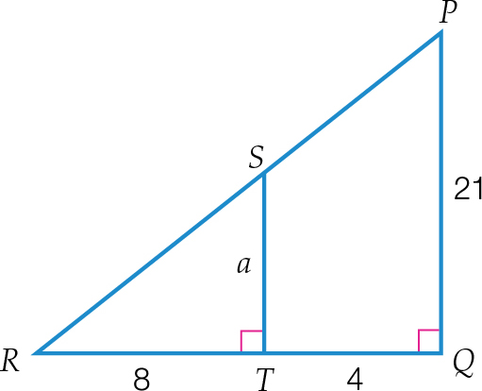

Question 20 3 marks [6.2]

Prove that ∆*DEH* ≡ ∆*GFH* and then find the value of *x*.

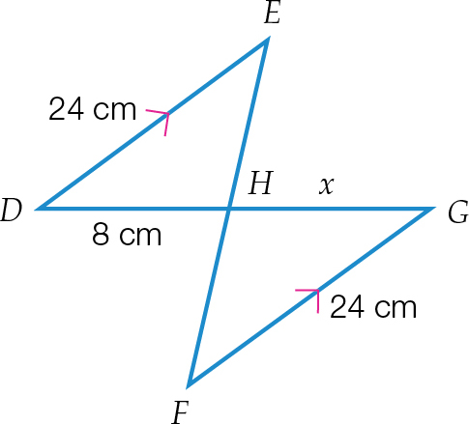

Question 21 3 marks [6.5]

∆*ABC* and ∆*KLM* are similar triangles.

∆*KLM* is shown here.

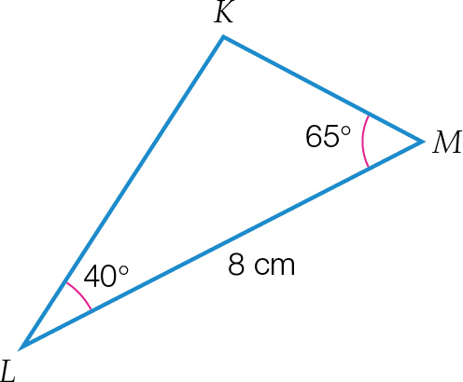

∆*ABC*: ∠*ABC* = 40°, ∠*ACB* = 65° and *BC* = 2 cm

Use this information to:

**(a)** determine the scale factor

**(b)** construct and correctly label ∆*ABC* to the correct scale, using a ruler and protractor.

Question 22 1 mark [6.4]

The area of a triangle is 90 cm2. What is the area of this triangle after the dimensions of the triangle have been reduced by a scale factor of ?

Short answer results: ___ / 50

Extended answer section

Question 23 9 marks [6.5]

*ABCD* is a quadrilateral in which the diagonal *AC* is drawn.

∠ *BAC* = 50°, ∠*BCA* = 20°, ∠*ACD* = 50°, ∠*ADC* = 110°

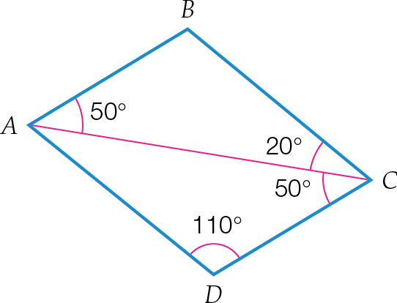

**(a)** Prove that ∆*ABC* is similar to ∆*CDA*.

**(b)** Is there enough information given to prove that ∆*ABC* ≡ *∆CDA*? Give your reasons.

**(c)** Explain why *AB* || *DC* and *AD* || *BC*.

**(d)** What special quadrilateral is *ABCD*?

Question 24 2 marks [6.6]

Sofia designed a window frame for her new house. Find the length of the brace needed.

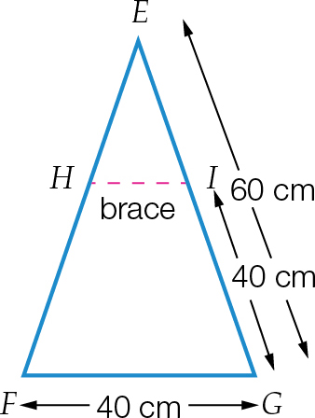

Extended answer results: ___ / 11

TOTAL test results: ___ / 69